**Data Driven Businesses with SQL & Tableau**

Set up the database

Before we can begin practicing SQL and exploring data, we’re going to need some data to explore. At the bottom of this page you’ll find a **Database dump** file to download. A database dump is nothing more than an SQL script that contains all the statements to:

* + 1. **Create a database**, also known as a schema.
    2. **Create all the tables within that database**. This step defines the columns for each table, their data types, and the relationships between the tables, such as primary and foreign keys.
    3. **Insert data into the tables**.

On many occasions, you will not have to set up the database from a dump file. Quite often you will simply connect to a database that lives in another computer (a *server*), either in the cloud or within the premises of a company. When this is the case, dumps are used to store a local back-up of the database in case of data loss. In our project though, you will use the dump to set up the database in your local computer.

With the dump file at the bottom of this page:

* + 1. Download the folder
    2. Unzip it
    3. Save it to an appropriate folder for this project

**TIP:**Be organised with your files. We recommend creating a folder for the bootcamp and then inside a folder for each project. Each project folder can contain a folder for data, another for scripts, another for resources, etc.

Once you have completed the steps above, open MySQL Workbench and connect to a local instance. You will need to input the root password you set when you installed MySQL Workbench during the Primer.

Once the connection is established follow these steps to import the database:

* + 1. On the top menu, click on Server > Data Import
    2. In the Administration tab that will open, select “Import from Self-Contained File”
    3. Navigate to the directory where you stored the dump file (publications_dump.sql) and select it.
    4. Click “Start Import” on the bottom right.

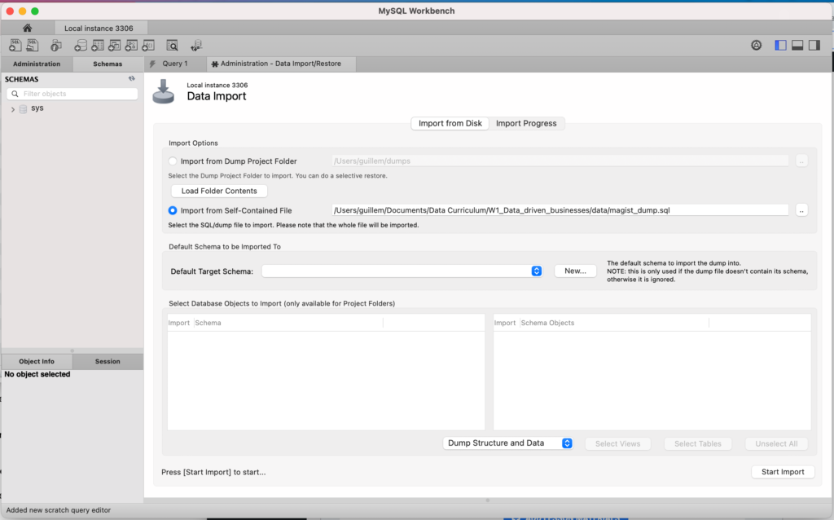

Depending on your computer, the dump takes between 10 seconds and 60 minutes to import – if it’s taking a while, please be patient.

After the import finishes, you can click the refresh button on the “Schemas” tab on the left side panel. A magist database should pop up there. Now you’re ready to query and explore the data!

**Publications dump**